Web: www.shinewithyvette.com

Main page/ chat option

As the customer enter the main page, he/she is able to scroll down (exploring the page).

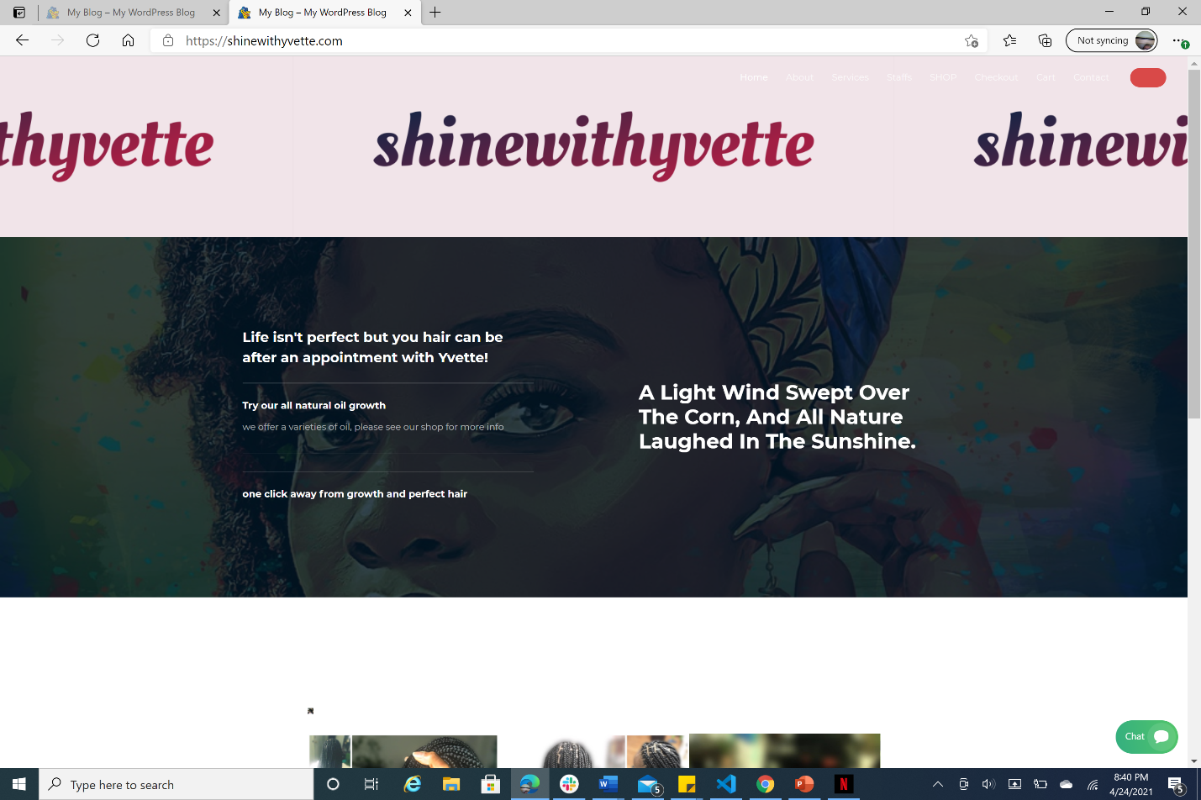

There is a library that displays the some of the work (services that are offered) and some of the products that can be purchased.

In the even that the costumers have any question(s), there is a chat option that is located down the page in green. Once that chat is clicked on, she/he can get in touch with the vendor/ hairdresser

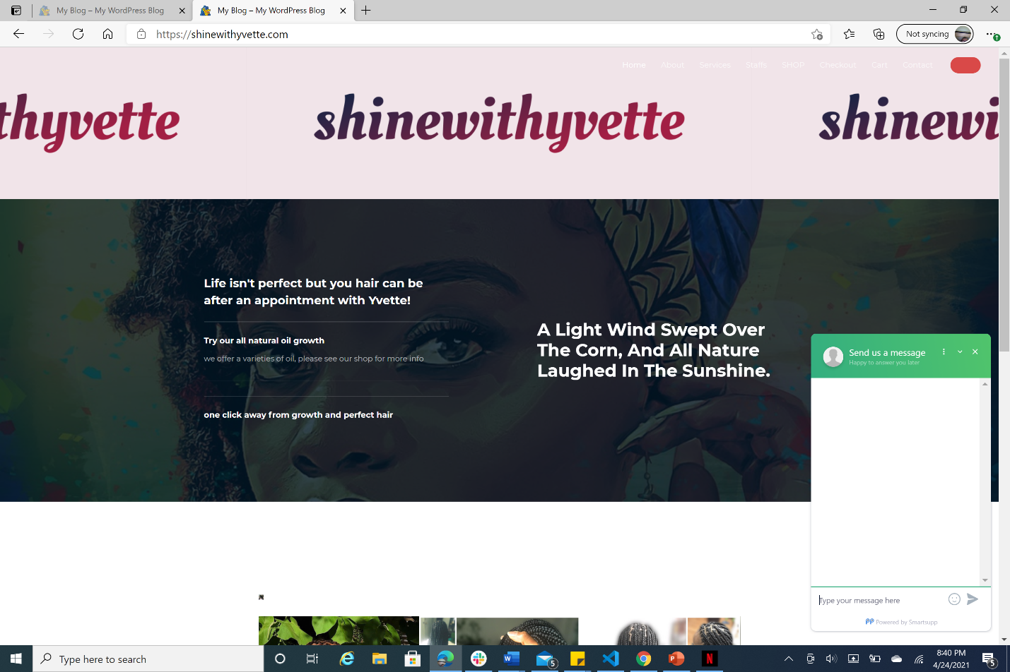

if the customer wants to see who the vendor or hairdresser is that have the option to click on staff and it will display the info needed.

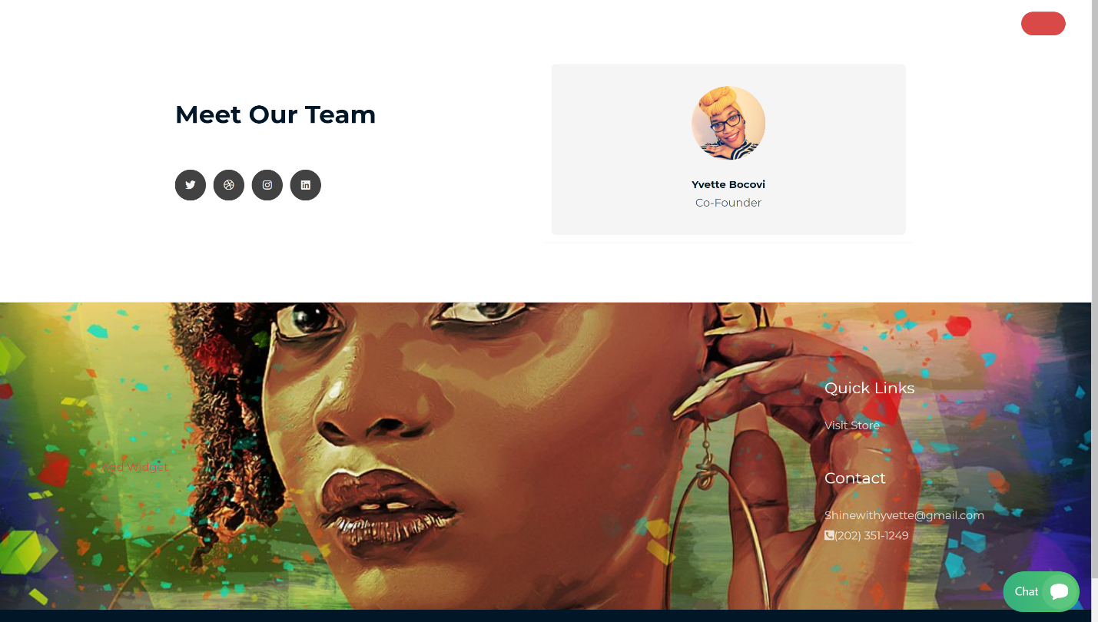

**Services:**

With one click, the customer is able to click on services and it will display the services that are being provided. To book an appointment, the costumer(s) must click on the Book Now button which is in blue.

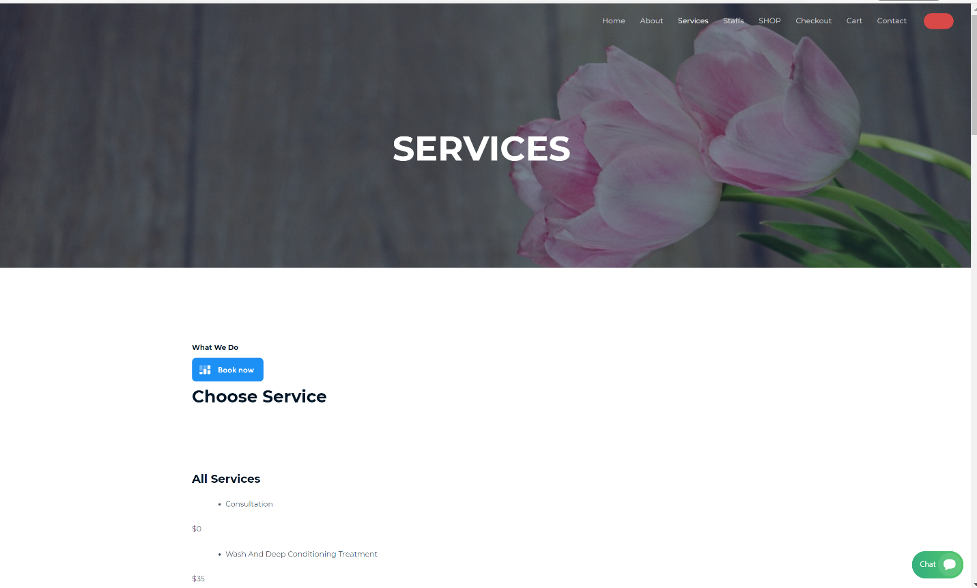

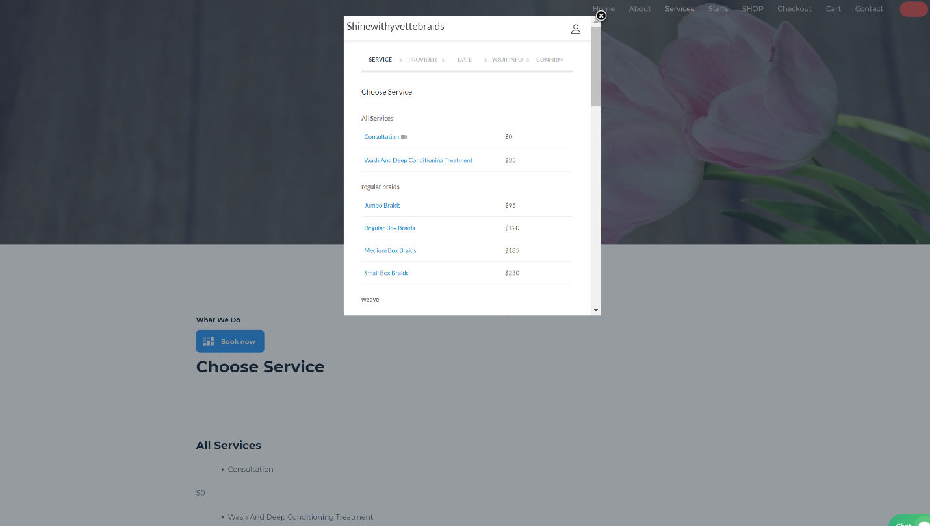

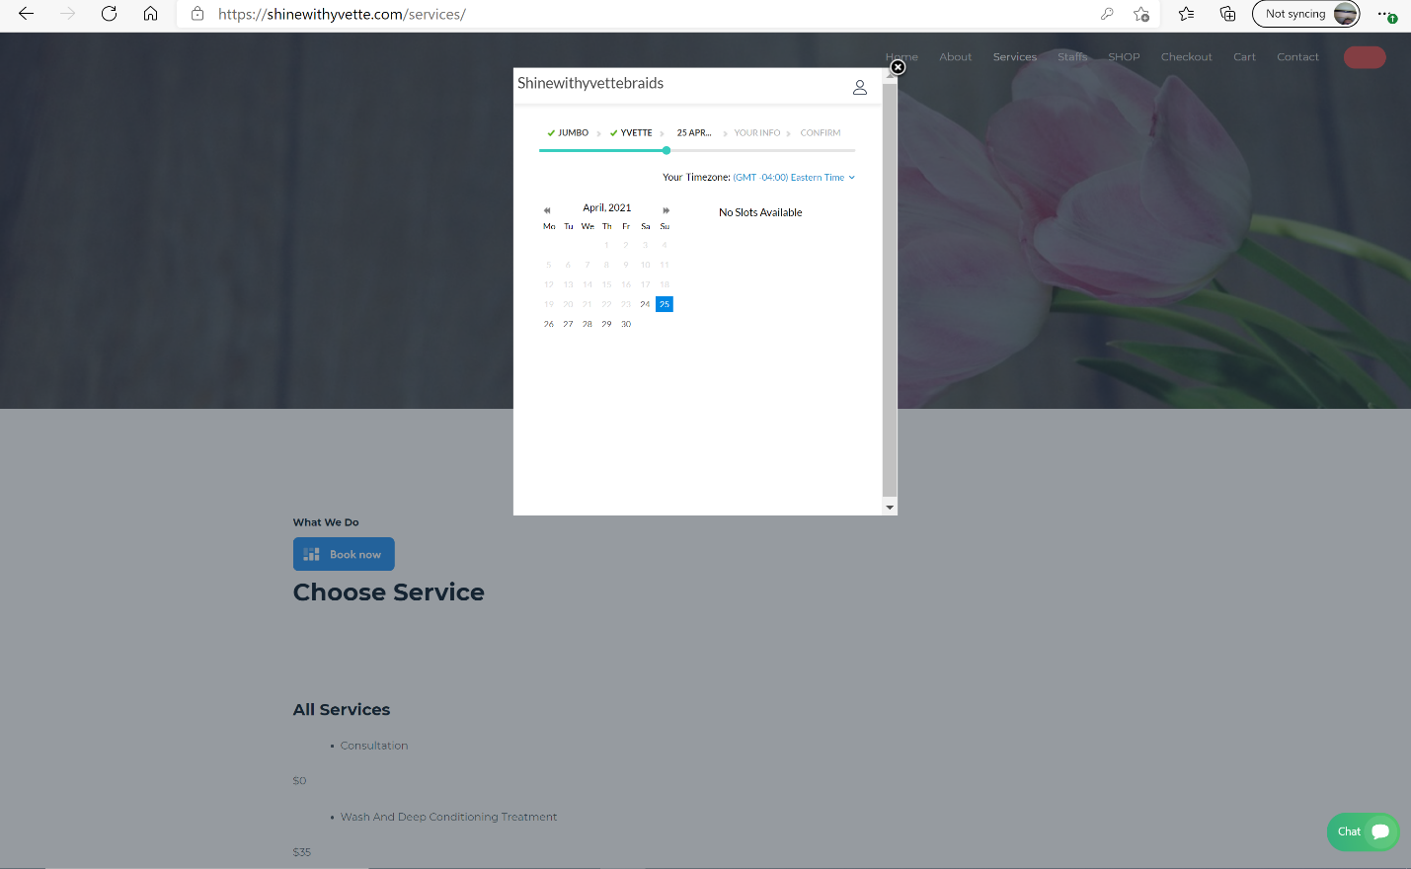

**SHOP: cart/check out**

If the customers want to buy hands scarfs or oils, head on to SHOP.

Once clicked on, it will display a variety of product. They customer(s) can click on (as many as they want)

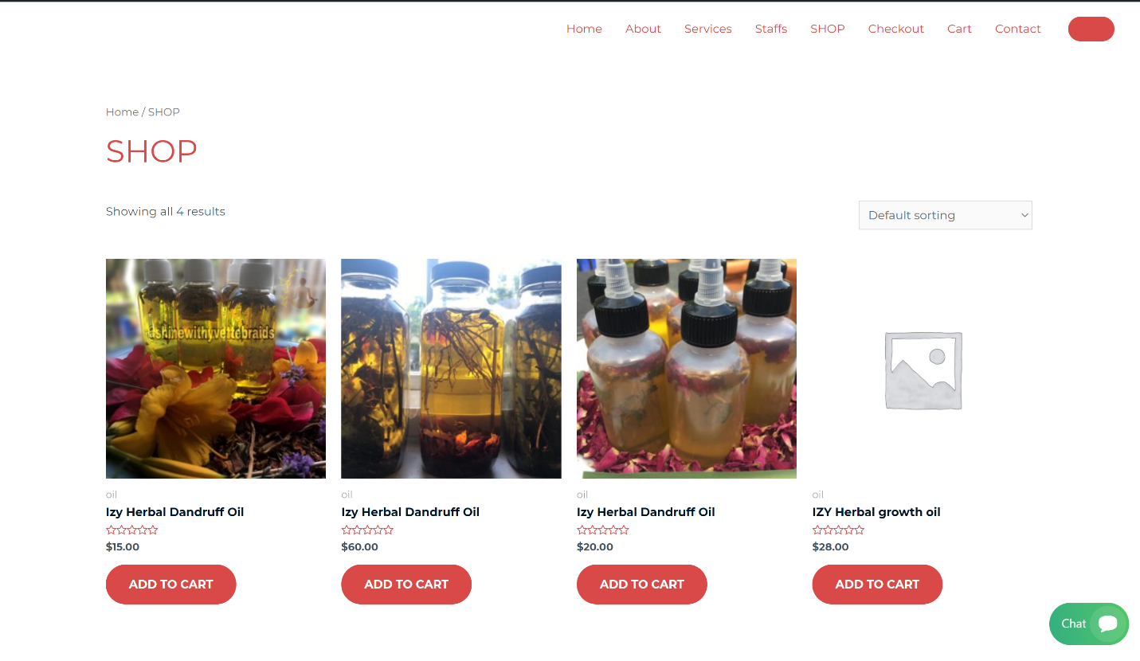

The customer can click on Cart to see what was selected. If satisfied she/he can head on to check out where she/he can finalize the sales by fille out the required info.

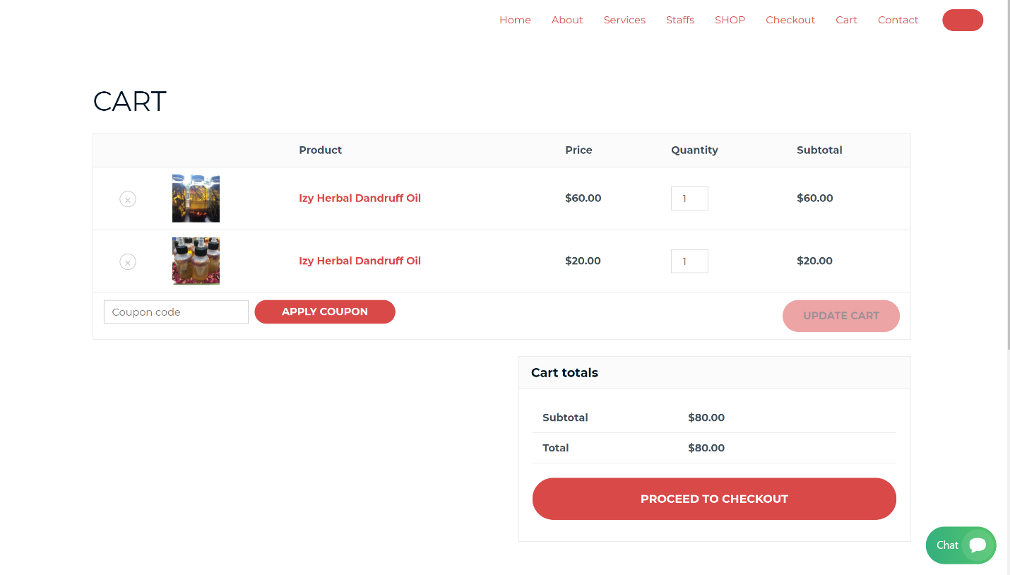

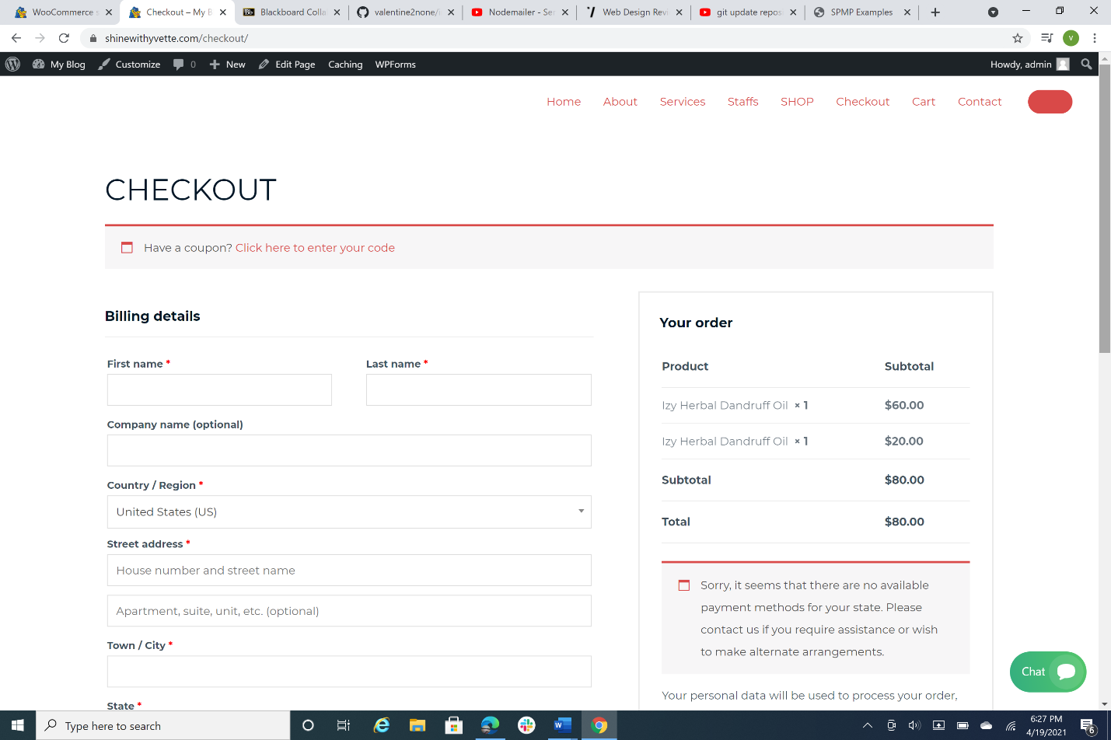

**Contact/Map:**

If the customers want to send an email to staff/hairdresser, they can click on contact and fill out the required filed. They also have access to a map where they can look what is in the area. For instance food ect….

